# Screen captures results:

## VARIANT 1:

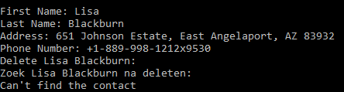

## VARIANT 2:

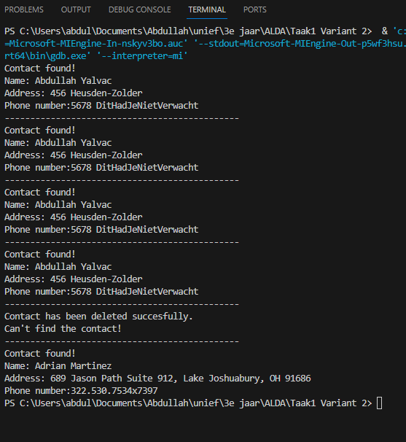

## VARIANT 3:

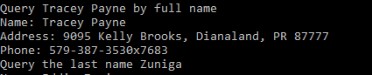

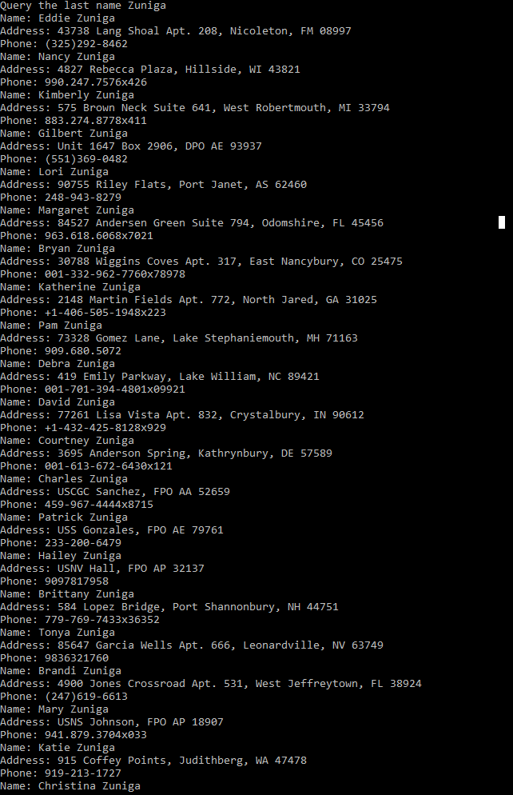

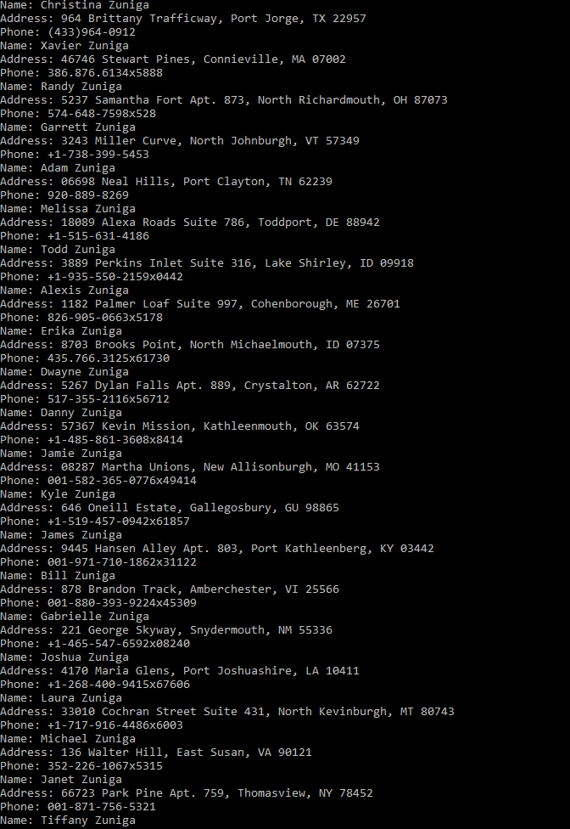

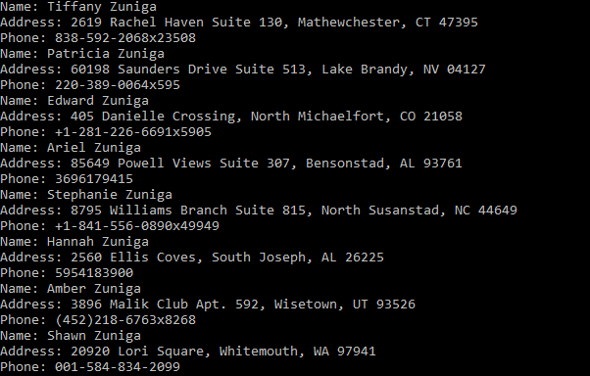

## DELETE AND QUERY CONTACT AGAIN



## SORT AND PRINT ADDRESSBOOK BY LAST NAME:

